Project Plan

< Sydney Stayz >

Joel Rosin, Danie Soulavy, Rahul Gupta

Table of Contents

1.0 Introduction 3

1.1 Background 4

1.2 Scope 4

1.3 Document contents 5

2.0 Work Breakdown Structure 7

3.0 Activity Definition & Estimation 10

4.0 Gantt Chart 16

# Introduction

## Background

The travel and hospitality industry was revolutionised with the development of Airbnb, by providing customers with a wider range of unique accommodation options to customers who would rather have an alternative to hotels. The resulting surge of Airbnb listings in Sydney has made it essential to gain an understanding of trends within the local Airbnb market.

With the vast amount of Airbnb Listings in Sydney, a need arises to produce easily understood insights from the large amount of data produced from the platform. Having user-friendly tools for data analysis and visualization will make it easier for property owners, guests and stakeholders to make more informed decisions.

The Sydney Stayz project aims to develop a data analysis and visualisation tool which is tailored to activity within the Syndey area. This tool will use an intuitive graphical user interface to explore analyse and visualise detailed yet concise data of Airbnb listings.

The project will focus its development on valuable insights to crucial market questions such as pricing trends, customer reviews related to cleanliness, amenities, property occupancy rates and which stay options are most popular in differing suburbs. By developing these functionalities, users of Sydney Stayz will be able to make more data-driven decisions, whether they’re planning for the perfect accommodation or property owners looking to improve their listings.

The project team will be using a centralised and regularly updated GitHub repository to efficiently develop the software, this ensures that all project members have a clear understanding of the projects progress and who made contributions. This facilitates a transparent development process and fosters better teamwork.

Ultimately Sydney Stayz seeks to enhance user understanding of Airbnb activity within Sydney, making it an important software tool for the hospitality industry, analysts, and anyone who’s interested in exploring the short-term rental market in Sydney.

## Scope

The scope of the Sydney Stayz project encompasses the development of a data analysis and visualization tool that focuses on providing insights into Airbnb activity in Sydney, NSW, Australia. The software will offer a user-friendly graphical user interface, enabling users to perform the following key features:

1. Listings Explorer:

- Users can select a specific suburb of choice to get detailed information about Airbnb listings within that area and chosen property type.

2. Price Distribution Chart:

- Users can select two different suburbs to create a graphical representation illustrating the distribution of property prices in Sydney.

- The chart will give insights into the range and frequency of property prices, helping users to identify pricing trends and fluctuations during different times of the year.

3. Cleanliness Comment Analyser:

- The tool will analyse comments to identify user comments related to property cleanliness.

- A predefined list of cleanliness-related keywords will be utilised; the software will create a report on customers who mentioned cleanliness in their reviews.

- The selection of keywords will be based on common associated with cleanliness, like "clean," "tidy," "hygienic," etc.

5. Additional Analysis: "Top-Rated Suburbs":

- The tool will feature an analysis tool that identifies the top user rated suburbs and property types.

- This analysis tool will showcase the most popular property's within different areas, providing valuable insights for guests and property owners.

The project will focus on Airbnb data in Sydney and won't expand its scope to include data from other cities or regions. The main goal is to create a simple, interactive, and user-friendly tool that allows users to gain important insights into the Airbnb market in Sydney.

The project will be hosted on a GitHub repository with access limited to group members, and regular commits will be made to showcase the collaborative progress of the project development process. Documentation and resources related to the project, including code, images, and others, will be stored within the GitHub repository for collaboration and version control.

## Document contents

1. Project Plan.docx:

- A project plan defining the scope, objectives, milestones, deliverables, and schedule for the Sydney Stayz project.

- Includes details on the team, resources, risk management, and communication strategies.

- The document serves as a roadmap for the project.

2. Software Design Document.docx:

- A software design document that provides an overview of the Sydney Stayz application.

- It outlines the system components, data flow, UI design, and data analysis to be implemented.

- The document serves as a layout for the development and ensures organised software design.

3. Gantt chart.xlsx:

- A representation of the project timeline, milestones, and task dependencies.

- The Gantt chart provides a high-level encapsulation of the project, helping to manage and track progress more effectively, allows for more flexible workflow.

4. git_log.txt:

- A file containing a record of commits made to GitHub during the project development.

- It tracks individuals' contributions, changes made, and version history, this ensures transparency and accountability during development.

5. All *.py files containing the data analysis program:

- A collection of Python scripts (*.py files) that make up the core data analysis and visualisation program for the project*.*

- These files implement the functionalities described in the project's scope.

6. User Manual.docx:

- A user manual providing instructions on how to use the *project* software.

- It includes screenshots and step-by-step guides on utilising the features and functionalities of the application.

7. Software Testing Report.docx:

- A testing report that outlines the strategy and objectives for the application.

- It includes unit tests and coverage test results to ensure the reliability of the data analysis program.

8. Executive Summary.docx:

- A executive summary that provides an overview of the project's progress over a 12-month period.

- It outlines milestones, outcomes, and future plans for the Sydney Stayz application.

9. Updated Project Plan.docx:

- An updated version for the project plan document reflecting any changes made during the development process.

- It includes an updated Gantt chart that showcases the new project schedule.

10. Updated Gantt chart.xlsx:

- An updated Gantt chart, outlining any changes in timelines, milestones, and task dependencies.

11. Updated Software Design Document.docx:

- An updated software design document reflecting on modifications made to the application's architecture.

12. Any other documents/supporting files:

- Extra files or resources that are considered necessary for proper documentation and understanding of the application. These might include diagrams, charts, or other project- related figures.

# Work Breakdown Structure

|  |  |  |
| --- | --- | --- |
| **Work Breakdown Structure** | | |
| **Task ID** | **Task Description** | **Predecessor** |
| 1. **Project Planning** | | |
| 1 | Define project scope and objectives | 0 |
| 2 | Identify stakeholders and their roles | 1 |
| 3 | Set up project repository on GitHub | 2 |
| 4 | Create initial project plan | 0,1,2 |
| 1. **Requirements** | | |
| 5 | Identify data sources and datasets | 1,3,4 |
| 6 | Identify analysis tools to be used | 5 |
| 7 | Data collection | 5,6 |
| 8 | Satisfy required features | 5,6,7 |
| 9 | Document functional and non-functional requirements | 3,4,5,6,7 |
| 1. **Design Phase** | | |
| 10 | Conduct initial design meeting | 8, 9 |
| 11 | Outline data analysis algorithms and methods | 10 |
| 12 | Plan initial Graphical User Interface design | 10, 11 |
| 13 | Create software design documentation | 11, 12 |
| 14 | Create software architecture diagrams | 11, 12, 13 |
| 15 | Prepare user manual outline | 11, 12 13, 14 |
| 1. **Implementation** | | |
| 16 | Develop initial data analysis functionalities | 15 |
| 17 | Create initial User Interface | 16 |
| 18 | Develop suburb Explorer functionality | 16, 17 |
| 19 | Create Price Distribution Graph Feature | 16, 17, 18 |
| 20 | Create keyword search function | 16, 17, 18 |
| 21 | Develop user cleanliness comment analyser | 16, 17 |
| 22 | Develop additional analysis tool for “Top-Rated suburbs and Property Types” | 16, 17, 18, 19 |
| 23 | Expand on user manual | 16, 17, 18, 19, 20, 21, 22 |
| 1. **Testing** | | |
| 24 | Prepare test cases | 23 |
| 25 | Conduct testing for each functionality | 24 |
| 26 | Perform User Interface testing | 24, 25 |
| 27 | Address and fix identified issues and bugs | 25, 26 |
| 1. **Finalisation and Documentation** | | |
| 28 | Review and update all project documentation | 27 |
| 29 | Create executive summary documentation | 28 |
| 30 | Conduct project review | 29 |
| 31 | Prepare project final submission and documentation | 28, 29, 30 |

No changes made to WBS as this flow remained consistent.

# Activity Definition & Estimation

Implementation, testing, Finalisation and Documentations areas of the Activity Definition and Estimation were added to reflect accurate reflections of estimates for each of these areas.

|  |  |  |
| --- | --- | --- |
| **Activity Definition & Estimation** | | |
| **Activity** | **Definition** | **Duration** |
| 1. **Project Planning** | | |
| **1. Define project scope and objectives** | The scope of the Sydney Stayz project involves the development of a data analysis and visualization tool for Airbnb activity in Sydney, NSW, Australia. The tool will offer features such as suburb exploration, price distribution chart, keyword search, cleanliness comment analysis, and additional analysis for top-rated suburbs and property types. The project will be focused solely on Airbnb data in Sydney and will be hosted on a GitHub repository with restricted access to group members.    The main objectives of the Sydney Stayz project are to create a user-friendly tool that allows users to gain insights into Airbnb activity in Sydney. The tool aims to provide detailed information about Airbnb listings in specific suburbs and timeframes, visualize property price distributions, enable keyword-based property searches, analyse comments related to cleanliness, and identify top-rated suburbs and property types. The project's goal is to deliver a simple, interactive, and valuable tool for guests and property owners, facilitating better decision-making in the Airbnb market in Sydney. | **2 hrs** |
| **2. Identify stakeholders and their roles** | **Daniel:** Project Manager  **Joel:** Data Analyst, Full Stack Developer  **Rahul:** Data Analyst, Front End Developer | **1 hr** |
| **3. Set up project repository on GitHub** | A GitHub repository was created where all project-related files, code, and resources are stored. Collaborators are invited to the repository, allowing them to contribute, manage, and track changes to the project's codebase and documentation. This enables seamless collaboration, version control, and progress tracking during the development process. | **0.5 hrs** |
| **4. Create initial project plan** | Creating the initial project plan involves outlining the project's introduction, which includes providing background information, defining the project scope, and listing the contents of the document. Additionally, it includes developing the work breakdown structure, defining project activities, estimating their durations and predecessors, finally, creating a Gantt chart to visually represent the project timeline and dependencies. | **5 hrs** |
| 1. **Requirements** | | |
| **5. Identify data sources and datasets** | The specific dataset chosen for this project is “Sydney Airbnb Data”. The relevant data sources can be found on Kaggle.com at the Sydney Airbnb Open Data section. The data sources required are from the Dataset Notebooks:  **Comparing Airbnb listing price (2018 and 2021)** **eda_airbnb_sidney**  **Starter: Sydney Airbnb Open Data cb6d1c39-2** | **1 hr** |
| **6. Identify analysis tools to be used** | The analysis tools used in the project are:  **Programming language:** Python  **IDE:** PyCharm **Python library:** Pandas | **2 hrs** |
| **7. Data collection** | Data collection is the process of gathering relevant and accurate information from various sources to populate the Airbnb data analysis and visualization tool for Sydney. This activity involves sourcing, retrieving, and aggregating data points necessary for the tool's functionality, including property listings, pricing information, geographical data, guest reviews, and cleanliness comments. | **10 hrs** |
| **8. Satisfy required features** | The features that are required are:  For a user-selected period, report the information of all listings in a specified suburb  For a user-selected period, produce a chart to show the distribution of prices of properties  For a user-selected period, retrieve all records that contain a keyword (user entered), e.g. pool, pet.  Analysing how many customers commented on factors related to cleanliness (multiple key words may be associated with cleanliness – justify your selection).  One other ‘insight’ or analysis tool of your choice | **10 hrs** |
| **9. Document functional and non-functional requirements** | **Functional Requirements:**    **Suburb Explorer:** Users should be able to select a specific period and suburb to retrieve detailed information about Airbnb listings within that area and timeframe.  **Price Distribution Chart:** Users should be able to select a date period to generate a graphical representation illustrating the distribution of property prices in Sydney during the chosen timeframe.    **Cleanliness Comment Analyser:** The tool must analyse customer comments to identify mentions related to property cleanliness using a predefined list of cleanliness-related keywords.  **Non-Functional Requirements:**    **Performance:** The tool should respond quickly to user queries and generate visualizations efficiently, ensuring a smooth user experience.  **Usability:** The user interface should be intuitive and user-friendly to cater to users with minimal technical expertise.  **Reliability:** The tool must handle errors and exceptions gracefully, providing informative error messages when necessary. | **5 hrs** |
| 1. **Design Phase** | | |
| 10. Conduct initial design meeting | Conducting the initial design meeting involves bringing together relevant stakeholders, designers, and team members to initiate the user interface design phase for the Airbnb analysis software. This meeting aims to establish a clear understanding of project requirements, objectives, and constraints, while also outlining the design approach and strategies. | **0.5 hrs** |
| 11. Outline data analysis algorithms and methods | Outlining the data analysis algorithms & methods involves defining the high-level strategies, techniques, and processes that will be employed to analyse the data within the Airbnb analysis software. This outlining phase aims to identify suitable algorithms, methodologies, and data processing steps required to extract meaningful insights from the collected data. | **3 hrs** |
| 12. Plan initial Graphical User Interface design | Planning the initial graphical user interface design involves outlining the strategic approach for creating the preliminary visual and interactive components of the Airbnb analysis software's user interface. This planning phase aims to define the design direction, layout, user interaction patterns, and overall aesthetics that will guide the subsequent design and development stages. | **4 hrs** |
| 13. Create software design documentation | Creating the software design documentation involves producing comprehensive documentation that outlines the architectural structure, components, modules, interfaces, and design rationale of the Airbnb analysis software. This documentation serves as a detailed guide for developers, designers, and stakeholders, facilitating the implementation phase and ensuring a clear understanding of the software's design. | **10 hrs** |
| 14. Create software architecture diagrams | Creating software architecture diagrams involve visually representing the structural and conceptual design of the Airbnb analysis software through diagrams that depict its components, interactions, and relationships. These diagrams provide a clear overview of the software's architecture and aid in understanding its design at a high level. | **3 hrs** |
| 15. Prepare user manual outline | Preparing the user manual involves structuring the framework and content organization for the user manual of the Airbnb analysis software. This outline will serve as a guide for creating a comprehensive and user-friendly manual that assists users in effectively using and navigating the software. | **2 hrs** |
| 1. **Implementation** | | |
| 16. Develop initial data analysis functionalities | Activity involves coding and development of the core data analysis functionalities within the Sydney Stayz application. | **40 hrs** |
| 17. Create initial User Interface | Initial user interface of app is created, includes graphical elements, layout and user interaction features. Serves as a prototype for testing | **10 hours** |
| 18. Develop Listing Explorer functionality | Allow users to select a date period and suburb, which gets information about the Airbnb listings within that area and suburb. | **8 hours** |
| 19. Create Price Distribution Graph Feature | Allow users to select a date period, price range and two suburbs for comparison, which generates a graph with the Airbnb listings within that area and suburb. | **10 hours** |
| 20. Create keyword search function | Allows users to select a date range and a specific keywork (e.g., "pool" or "pet") to refine results to properties that are available to rent and include that amenity | **9 hours** |
| 21. Develop user cleanliness comment analyser | cleanliness comment analyser identifies comments left by previous customers that are related to cleanliness from a pre-defined list of keywords. | **6 hours** |
| 22. Develop additional analysis tool for “Top-Rated suburbs and Property Types” | Provides insights into what properties are more popular by selecting a property type and suburb location. | **8.5 hours** |
| 23. Expand on user manual | User manual for the software is developed to include instructions and explanations for using the features. Ensures that users can navigate and utilise all the software functionality | **4 hours** |
| 1. **Testing** | | |
| 24. Prepare test cases | This involves creating detailed test cases which outline the expected outcomes, inputs and specific test scenarios for the software | **10 hours** |
| 25. Conduct testing for each functionality | The software is tested rigorously against each test case. Functionalities are evaluated to identify any issues with the code. | **7 hours** |
| 26. Perform User Interface testing | Ensure the user interface is issue free, like layout issues, visual design and navigation are user-friendly and error free. | **5 hours** |
| 27. Address and fix identified issues and bugs | Any issues which are identified are reported and resolved. | **8 hours** |
| 1. **Finalisation and Documentation** | | |
| 28. Review and update all project documentation | All documentation is thoroughly reviewed and updated. | **12 hours** |
| 29. Create executive summary documentation | Provides a concise overview of the whole project. Highlighting key outcomes and insights. | **6 hours** |
| 30. Conduct project review | Involves assessment and evaluation of the entire project. Discussions are held to talk about the success of the project, what lessons were learned and areas for future improvement. | **3 hours** |
| 31. Prepare project final submission and documentation | Final step, all deliverables, documents and resources are gathered and organised for submission. | **5 hours** |

# Gantt Chart

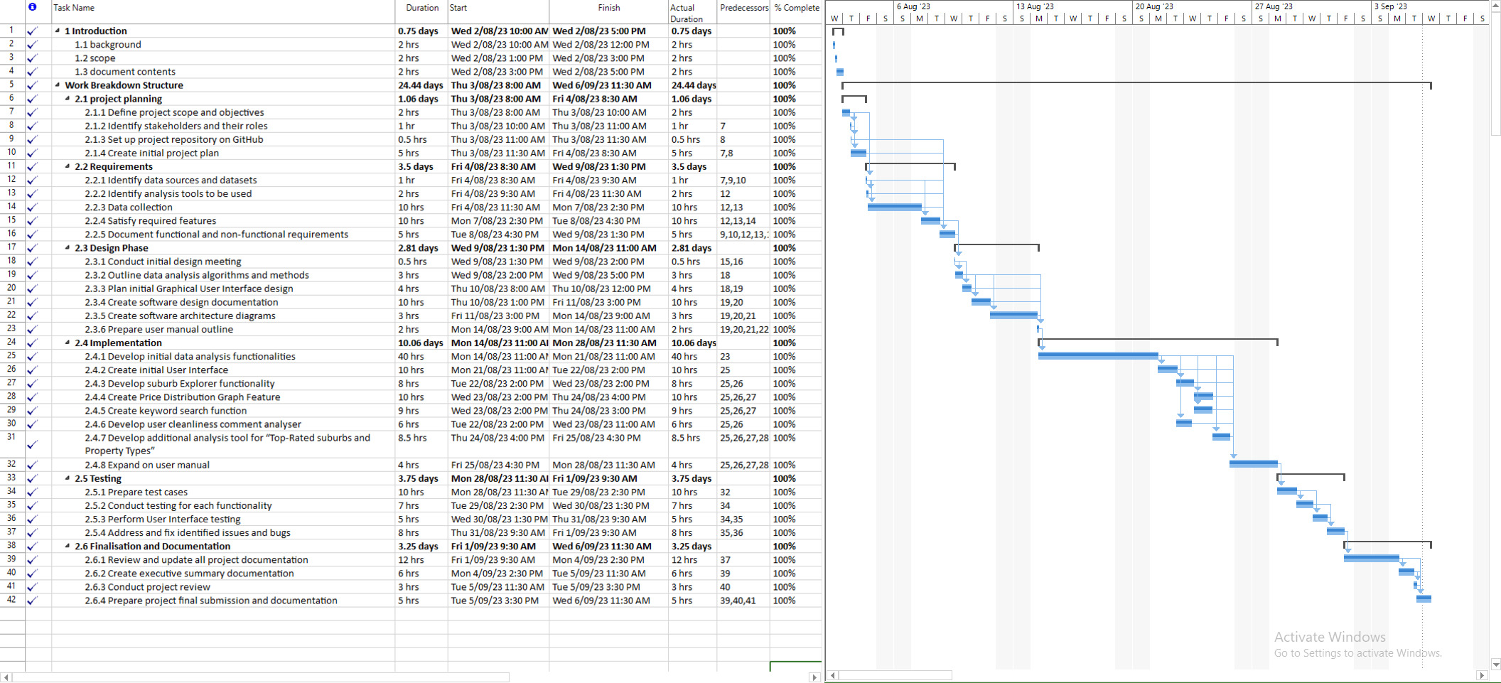

# Updated Visual Design

The overall Graphical Interface was changed dramatically during the creation of software because the original design was for a mobile device, however displaying the data in a easy to read manner proved too difficult to justify using that design. So, we have switched to a desktop only design to be able to display the generated data more effectively. A more in-depth updated view of the graphical interface can be seen in 4.2 Visual Design in the Software design Document. See Fig 2.0 for the amended Main Menu screen.

Additionally, in making the decision to move away from the mobile application design and move towards a desktop centric design, the group decided to remove the subicons which were mentioned in; assignment 1, 4.1 Structural Design section. The following subicons were removed:

* Favorites Icon
* Support Chart Icon
* Profile Icon

The decision was then made to upgrade the Keyword Search to one of the main components within the Sydney Stayz data analysis software.

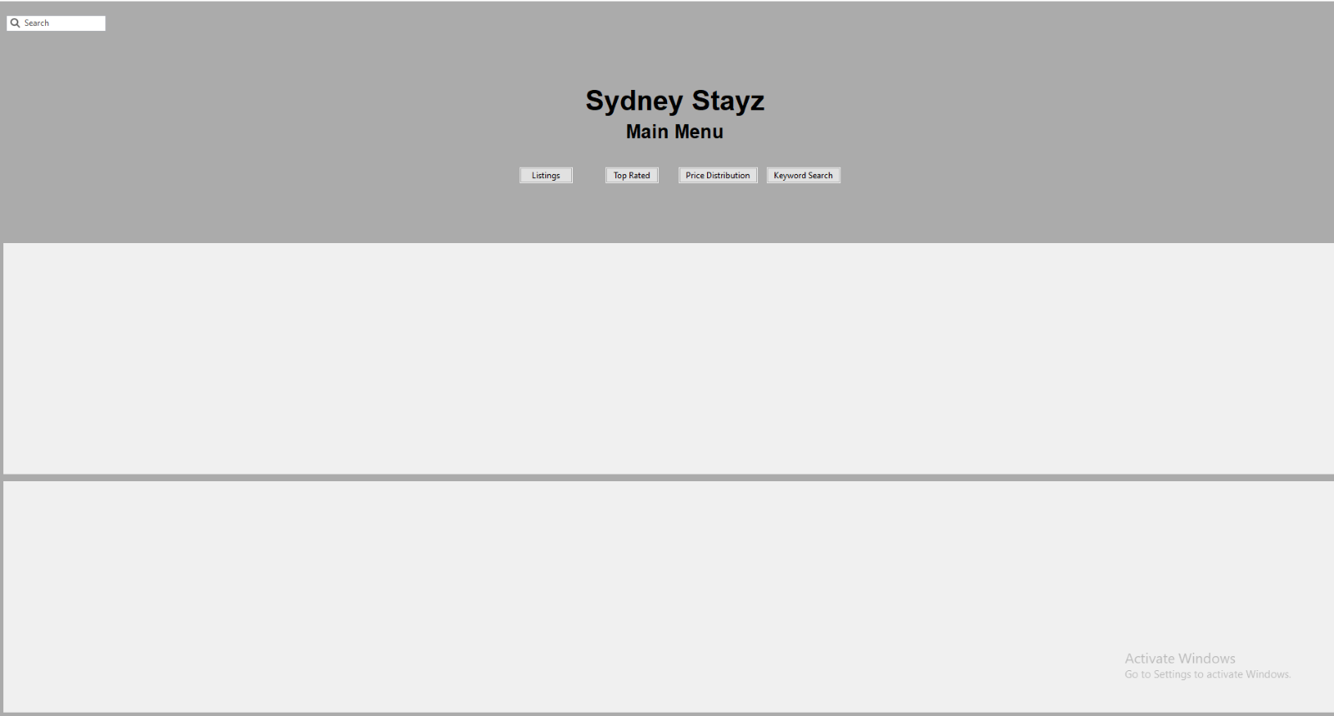  
Fig 2.0

# Updated Function

Originally, we planned to use a calendar function as one of the implemented features, however this function ended up being a bit too simple. The changed function now utilises the features that were present in the calendar as well as adding a keyword search, which allowed for users to find properties that are available within that date selection that contain the keyword that was searched for. The software design document reflects this change of functionality in more detail.